PERIOD 3: REGIONAL AND INTERREGIONAL INTERACTIONS, 600 – 1450

The Resurgence of Empire in East Asia

- The Restoration of Centralized Imperial Rule in China
  - Sui Dynasty (589-618)
    - Rise to Power - Yang Jian imposed tight political discipline on his state and began his rise to power when a Turkish ruler appointed him duke of Sui in northern China. His patron died, leaving only a young boy as son. One year later, Yang forced the abdication of this son, claiming the throne and the Mandate of Heaven.
    - Grand Canal - The elaborate project that the Sui dynasty undertook was the construction of the Grand Canal, a large waterworks project. Its intention was to facilitate trade between northern and southern China, particularly to make supplies of rice and other food crops available to residents of northern regions. It became 1,240 miles long, and was very expensive to construct. The canal lasted until the present day and is still functional.
    - Decline of Sui Dynasty - Dependence on high taxes and forced labor made the Sui dynasty unpopular. In 618, Sui Yangdi was assassinated by a disgruntled minister.
- The Tang Dynasty (618-907) - was established by a rebel leader after the death of Sui Yangdi in 618
  - Tang Taizong - The second emperor of the Tang Dynasty that ambitiously and ruthlessly made his way to the imperial throne, murdering two of his brothers, and pushing his father aside. His capital at Chang’an was awesome, and he relied on the Mandate of Heaven as a self-professing Confucian ruler. Tax rate was around 2.5 percent, which is extraordinarily low. Three policies in particular made Tang Taizong popular:
    - Transportation and Communication - maintaining the Grand Canal, extensive roads networks, and horses and human runners for post and message services. Established inns, postal stations, stables, etc. for couriers that could relay messages across the most distant cities within 8 days.
    - Equal-Field System - The allocation of land was made equal to avoid concentration of landed property that leads to social problems, such as in the Han dynasty.
Worked like this: land was allotted according to family needs and the land’s fertility. One fifth of the land became hereditary, and the rest was redistributed when the original recipients’ needs changed. For a century, highly successful. By the early 700s, however, it did not do so well, because some wealthier families found ways to retain land scheduled for redistribution.
    - Bureaucracy of Merit - Tang relied on bureaucracy of merit reflected by performance on imperial civil service examinations. These focused on Confucian curriculum, and allowed office holders to come from the ranks of common families.

  - Tang Military Expansion - Tang forces conquered Manchuria and part of Vietnam. Territorially, the Tang was one of the largest in Chinese history.
  - Tang Foreign Relations - Revival of tributary relationships, wherein China was considered the “Middle Kingdom.”
  - Tang Decline - The emperor neglected his duties after 755, and a man named An Lushan led a rebellion and captured the capital at Chang’an. In 757, a soldier murdered An Lushan, and by 763 Tang forces had suppressed his army and recovered their capitals. Unable to defeat the rebels, the Tang invited a nomadic Turkish people named the Uighurs to bring an army into China. After this affair, the equal-field system deteriorated, and tax receipts no longer funded the empire. A series of rebellions, especially one led by Huang Chao beginning in 875, left China in chaos. By 907, the last Tang emperor abdicated his throne, ending the dynasty.
- The Song Dynasty (960-1279)
  - Song Taizu - The first emperor (r. 960-976) placed emphasis on civil administration, industry, education, and arts, neglecting military affairs. He and his armies subjected the warlords to their authority, convincing his generals to retire honorably to a life of leisure. All state officials were regarded as servants of the imperial government. Officials were rewarded handsomely, expanding the bureaucracy based on merit unified China.
  - Song Weaknesses - Two major problems that led to the fall of the Song Dynasty:
    - Bureaucracy devoured China’s surplus production
    - Military was led by scholar-bureaucrats who had little military education. The Khitan, a seminomadic people from Manchuria, ruled a vast empire in northern China and even captured the Song capital at Kaifeng, establishing the Jin empire. The latter part of the dynasty is called the Southern Song because the emperors moved to a southern capital at Hangzhou. Mongol forces ended the dynasty in 1279 and made China part of their empire.

Economic Development of Tang and Song China

- Agricultural Development
  - Fast-ripening Rice - LIke the Muslims who encountered high-yield, nutritious crops, the Chinese ventured into Vietnam and found fast-ripening rice that would allow two harvests per year. The use of heavy iron plows and oxen helped propel food production forward. Extensive irrigation, including reservoirs, dikes, dams and canals also helped develop agricultural potential.
  - Population Growth & Urbanization - Chinese population grew from 45 million in 600 C.E. to 50 million in 800 C.E. By 1000 C.E. it had grown to over 60 million, whereas by 1200 (after the 1127 conquest of northern China by the Jurchen state) China had a population of 115 million.

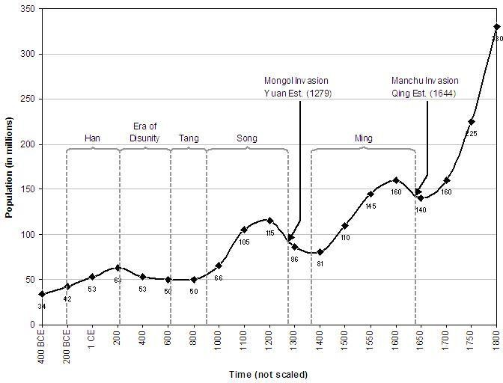

This growth reflected increased productivity and the well-organized distribution of food through transportation networks. It led to rapid urbanization during the Tang dynasty, until the Song Dynasty, when China became the most urbanized land in the world. There were many Chinese cities with populations of over 100,000 people.
  - Patriarchal Society - Increasing wealth led to a patriarchal society in which practices such as foot-binding became increasingly popular. It involved wealthier families, but placed women under the strict supervision of their husbands and male guardians.
  - Wu Zhao: The Empress - A rare female ruler named Wu Zhao ruled from 626-706 C.E. She was the daughter of a scholar-official, and the concubine of Tang Taizong, where she became successor. In 660, after the emperor had a stroke, Wu Zhao became empress regnant. This went against Confucian principles, and Wu Zhao had to hire a secret police force to monitor dissidents. She quashed rebellions and organized military campaigns. She was forced to abdicate in favor of her son, and is remembered as the only empress.
- Technological and Industrial Development
  - Porcelain - Abundant food supplies led to a rise of porcelain production, which was tougher and lighter than other potteries of history. It diffused to other societies, and Abbasid crafts workers in particular competed. Tang and Song porcelain existed all along the trade networks of the postclassical era: Chinese porcelain graced the tables of wealthy and refined households in southeast Asia, India, Persia, and the port cities of east Africa.
  - Metallurgy - The production of iron and steel surged because of techniques that resulted in stronger and more useful metals. Between the early ninth and twelfth centuries, iron production increased almost tenfold according to official records, which understate total

production. Arrowheads, bridges and pagodas, and other building projects also required iron and metals.
  - Gunpowder - Daoist alchemists discovered gunpowder during the Tang dynasty, and learned that it was unwise to mix charcoal, saltpeter, sulphur, and arsenic, because the concoction involved destroyed buildings.
  - Printing - Block printing techniques became popular in China during the Tang dynasty. Reusable, movable type was popular as of the mid-eleventh century.At first, printed copies of Buddhist texts, Confucian works, calendars, agricultural treatises, etc. were very popular.
- Emergence of a Market Economy - increased productivity and improved transportation led to the emergence of a market economy. The government bureaucracies still distributed staple foods such as rice, wheat, and millet. Fruits and vegetables became available for sale on the free market.
  - Financial Instruments - Alternatives to cash known as letters of credit or even “flying cash” became available. These allowed merchants to deposit goods or cash in one place and draw the equivalent in cash or goods elsewhere in China. Paper money also became important as copper became less readily available for coins because of the free market. Paper money provided a powerful stimulus for the Chinese economy, but sometimes did not fetch the value of the coin.
  - A Cosmopolitan Society - Trade came to China both by land and sea, as Muslim (Abbasid) merchants helped revive the silk roads network of the classical era. Bustling south Chinese ports arose as Arab, Persian, Indian, and Malay traders participated in the Indian Ocean trade.

Cultural Change in Tang and Song China

- Cultural Change in Tang and Song China
  - Foreign religions established themselves in China after the fall of the Han in part delegitimized Confucianism. Christians, Manichaeans, and Zoroastrians fled Islamic conquerors of Persia to establish new communities in China.
  - Buddhism in China - Buddhism had come to China via the silk roads, and a Buddhist community had emerged at Dunhuang in western China between 600 and 1000. Buddhists built cave temples near the city, decorating them with murals and depicting events in the lives of the Buddha and the bodhisattvas. High standards of morality and intellectual sophistication as well as the promise of salvation was attractive in China.
  - Buddhism Challenges Chinese Cultural and Social Traditions - Like Confucianists, Buddhists written texts. By focusing on metaphysical issues, however, Buddhism undermined Confucianists, emphasizing the journey towards an ascetic ideal. This led to Daoist and Confucian persecution of Buddhist. In the 840s, Tang emperors had monasteries closed and had Buddhist, Zoroastrian, Nestorian Christian, and Manichaeans expelled. This helped them seize property, for the most part...
  - Xuanzang’s Journey - Xuanzang made a journey to India to visit holy sites and learn Buddhism (see intro to chapter).
  - Neo-Confucianism & Zhu Xi - Neo-Confucianism mixed with Buddhism, which understand the nature of the soul and the individual’s relationship with the cosmos. This
metaphysical dimension had been lacking from Confucianism. Zhu Xi was fascinated with Buddhism, but became famous by writing a treatise entitled Family Rituals in which he

described how weddings, funerals, ancestor veneration, and other ceremonies should be practiced.

